Steps to Integrate Ngrok with a Go Web Application

Step 1: Install Ngrok

* Once ngrok downloaded,set up the system path in environment variable with ngrok path.

Step 2: Create a file named main.go with the following content:

Package main

import (

"fmt"

"log"

"net/http"

)

func homeHandler(w http.ResponseWriter, r *http.Request) {

fmt.Fprintf(w, "Hello, world!")

}

func main() {

http.HandleFunc("/", homeHandler)

fmt.Println("Server is running on http://localhost:8080")

log.Fatal(http.ListenAndServe("127.0.0.1:8080", nil))

}

Step 3: Run Go Server Locally

* go run main.go

Step 4: Sign Up and Get an Authentication Token

* Sign up for an account on the Ngrok website:<https://dashboard.ngrok.com/signup>
* Go to the following link to get your authentication token:<https://dashboard.ngrok.com/get-started/your-authtoken>
* Copy the authentication token provided.

Step 5: Configure Ngrok with Your Authentication Token

* Run the following command to set up your authentication token in VS Code:
* ./ngrok authtoken<your_auth_token>

Replace <your_auth_token> with the authentication token you copied from your Ngrok account.

Step 6:After configuring your authentication token, run the following command to start an HTTP

Tunnel on port 8080.

* ngrok http 8080 *where 8080 is port no.*

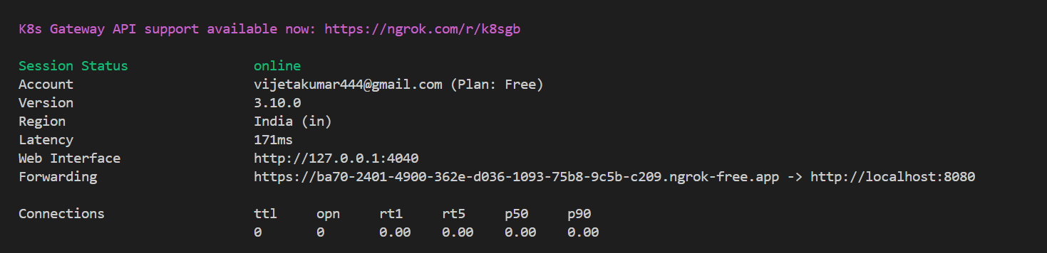

Step 7: Run the following command to start a TCP tunnel on port 8080:

* ngrok tcp 8080

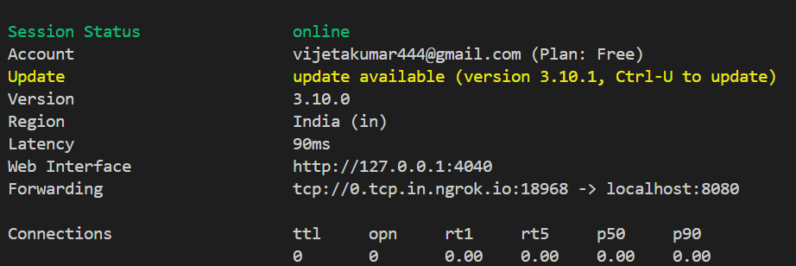

IMPORTANT NOTE: Ensure that your local firewall and network settings allow traffic through

Port 8080.